**CICD EXPERIMENT – 10**

**Nexus Integration with Jenkins**

1. Start the Jenkins service and go to localhost:8080 on a web browser
2. Go to manage Jenkins, then go to Install Plugins and install “Sonatype Nexus Server”

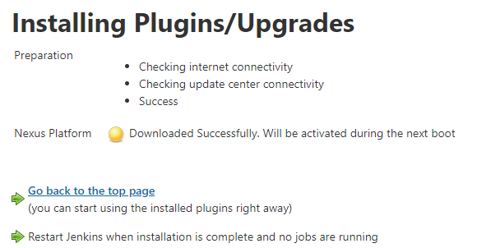

1. Now go to “Global Configurations”, then JDK installations tab and add name and location of JDK present in your machine.

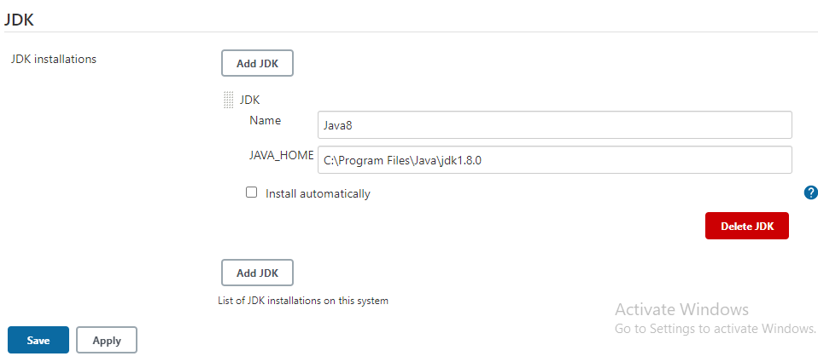

1. Now select “Source Code Management” tab enter the URL of the github repository you want to integrate with

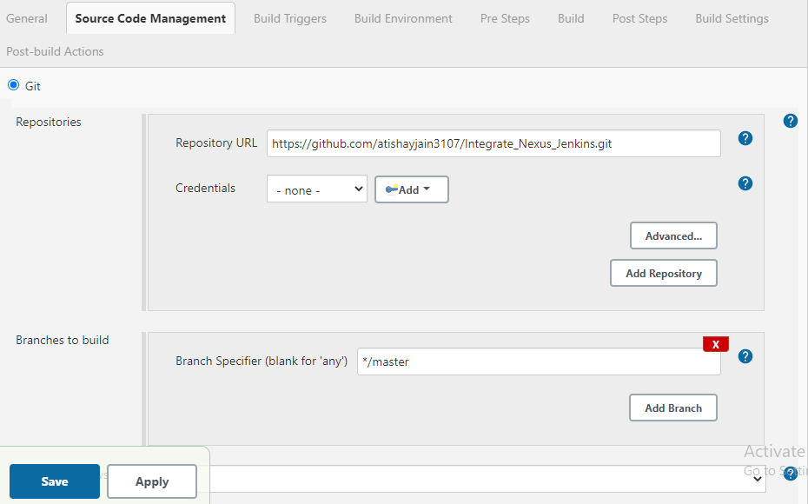

1. Select “Build” tab and add location of the pom.xml file in your github repository and the goal you want to run

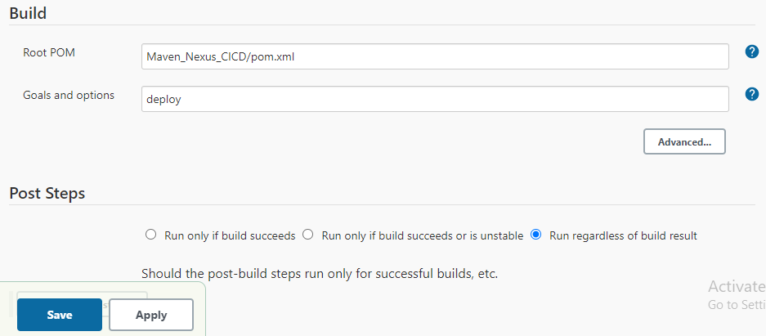

1. Now go to “Configure Systems” option in Manage Jenkins and search for the tab “Sonatype Nexus”. Enter the details for the same and run the “test connection” option to check whether connection is connected or not

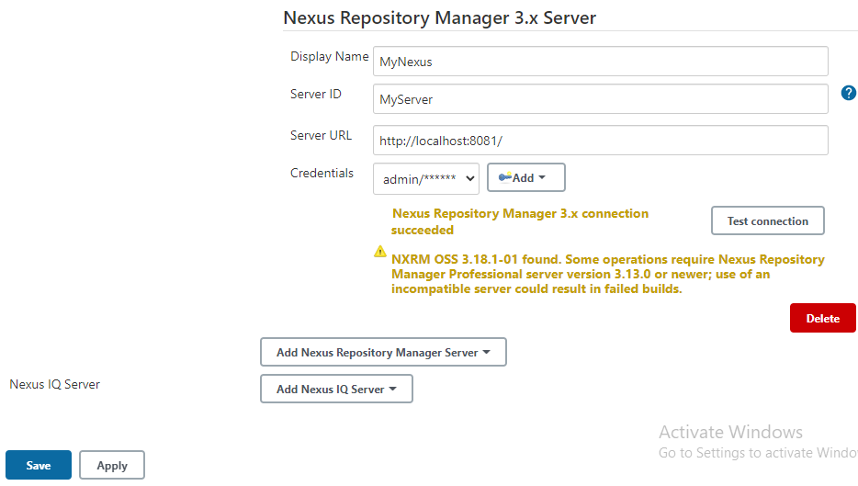

1. Now after connection is successful, save the changes and you will be directed to Jenkins dashboard page. Select option build now and go to console output option to check the output

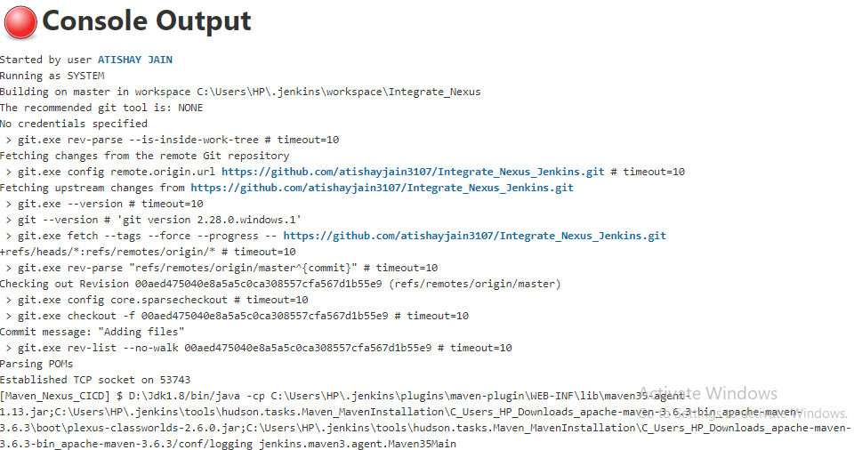

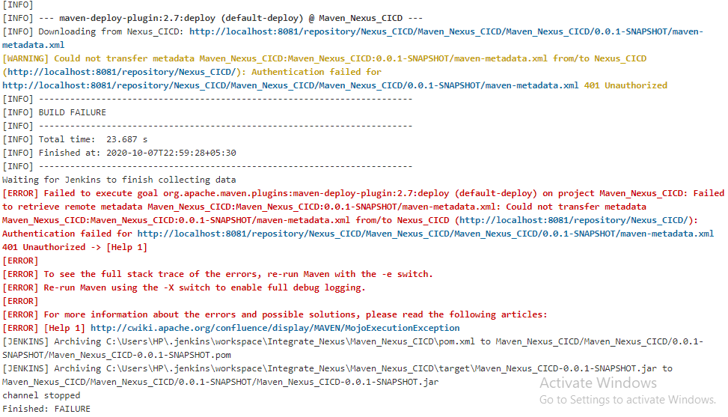

ATISHAY JAIN

500067694

R171218030

CSE, DEVOPS